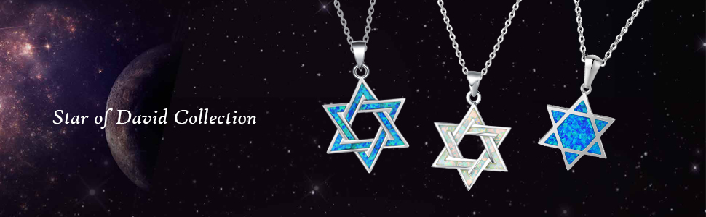

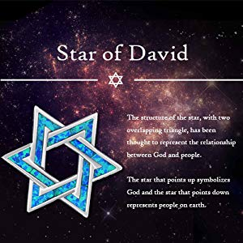

### Star of David

The structure of the star, with two overlapping triangle, has been thought to represent the relationship between God and people.

The star that points up symbolizes God and the star that points down represents people on earth.

Nowadays, Star of David is also a popular fashion element, wide used in jewelry, tattoo and other fashion filed.

**FANCIME** choose this fashion element to deliver faith and hope.

**FANCIME** Star of David Collection is well crafted in created opal, the blue and white opal is vivid and energetic to fresh your look.

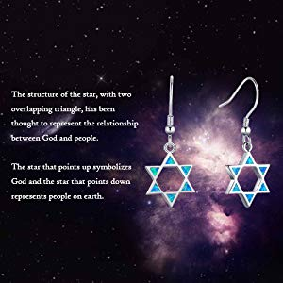

### Matching Star of David Dangle Earrings

The **FANCIME** Star of David Collection does not only contains beautiful necklace, but also elegant earrings.

Our Star of David Drop Earrings are special and vivid. Hollow design makes the earrings light to wear, and easy to swing without causing burden to your ears.

The entire collection is made of 925 sterling silver and crafted in created opal,

all metals are lead free, nickel free and hypoallergenic.

|  |  |  |
| --- | --- | --- |
| **Fine jewelry** | **Extender** | **Gift box** |
| Fine Jewelry F**ANCIME** Star of David Necklaces are well crafted in sterling silver and created opal.  All metals are lead free, nickel free and hypoallergenic. | Adjustable Chain All our necklaces are adjustable.  Chain can be adjusted from 16" to 18" according to needs. | Gift Box avaliable All our jewelry products come with an elegant gift box. Save your trouble and money to buy extra gift box. |

**OUR MISSION & BELIEFS**  
We believe every woman and man is beautiful and should be celebrated!   
  
Our mission at IceCarats is to celebrate our customers and enhance their lives journey, inspiring creativity, honoring life's memorable occasions and enhancing the beauty of everyday through our extensive collection of quality jewelry as a way to express your personal art and style.  
  
In search of the most naturally, beautiful gems and precious metals we travel across the globe to ensure that our stunning designs and raw materials are sourced from the best areas on the globe, we do this in order to exceed what our devoted customers have come to expect. Whether you’re buying everyday statement pieces for yourself or precious stones for a loved one, we aim for quality and style to merge together seamlessly without sacrifice.

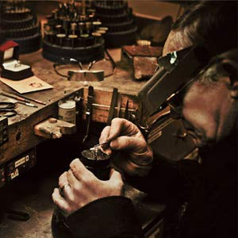

**THE ICECARATS STORY - CRAFTSMANSHIP...QUALITY...VALUE**  
  
Jewelry is our passion - IceCarats is devoted to craftsmanship, quality, and value.   
  
Whether you’re looking to shine at your next happy hour, or cocktail party, or for a special gift, IceCarats has got you covered, with an endless selection that is just right for you. IceCarats jewelry brings you the must-have looks for less without ever compromising quality. We know you are going to love your IceCarats jewelry and we are pleased to offer a vast selection that suits every occasion.  

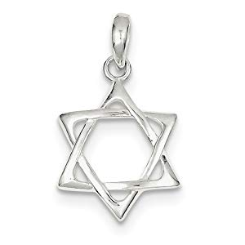

**MADE WITH LOVE FROM US TO YOU -**  
**QUALITY WITHOUT COMPROMISE**  
  
When you purchase jewelry from the IceCarats collection, you buy with confidence.   
  
IceCarats Designer Jewelry is passionately designed with premium quality material. Each piece in our collection is meticulously handcrafted by master artisans and our attention to detail is unmatched. Every item is carefully measured and inspected to ensure only the finest gems and precious metals carry our name.

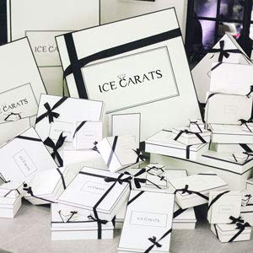

**ELEGANT GIFT PACKAGING -**  
**JUST ANOTHER REASON TO SAY YES!**  
  
Receive Elegant Gift Packing On Every Order with IceCarats!   
  
No matter what you're celebrating, every jewelry purchase is special. To us, that means completing your order with packaging as distinctive and sophisticated as your new jewelry. Whether it's a gift for a loved one or a treat for you, we strive to make every order perfect. Whether you are buying the product for yourself or for someone special, we want everyone to be impressed.